Wildlife Tracker Tool

User Manual

Farheen Aslam

# Contents

1. Contents 2

2. Table of Figures 3

3. Introduction 4

3.1 Purpose and scope 4

4. Application Features 4

4.1 Quick Tour 4

5. pRODUCT Basics 5

Getting Started 5

5.1 Main Screen 5

5.2 Category 6

5.2.1 List Categories 6

5.2.2 Add Category 6

5.2.3 Delete Category 7

5.3 GPS Device 8

5.3.1 List Animals 8

5.3.2 Add Animal 9

5.3.3 Delete Animal 9

5.4 Locate Animals 10

5.4.1 Locate Animals In All Category 10

5.4.2 Locate Animals Per Category 11

5.5 Locate Animals 11

5.5.1 Generate the Report 11

# Table of Figures

[**Figure 1 MAIN SCREEN 5**](#_Toc452555137)

[**Figure 2 LIST OF CATEGORIES 6**](#_Toc452555138)

[**Figure 3 ADD cATEGORIES 7**](#_Toc452555139)

[**Figure 4 CONFIRMATION MESSAGE 7**](#_Toc452555140)

[**Figure 5 LIST OF ANIMALS 8**](#_Toc452555141)

[**Figure 6 Add ANIMAL 9**](#_Toc452555142)

[**Figure 7 Successful animal added message 9**](#_Toc452555143)

[**Figure 8 DELETE ANIMAL SUCCESSFULL MESSAGE 10**](#_Toc452555137)

[**Figure 9 LOCATE ANIMAL IN ALL CATEGORIES 10**](#_Toc452555138)

[**Figure 10 LOCATE ANIMALS PER CATEGORY 1**](#_Toc452555139)**1**

[**Figure 11 generate animals per category 1**](#_Toc452555139)**2**

# Introduction

## Purpose and scope

This document contains the information for working of the Wildlife Tracking Tool. This application is an application for tracking a animal over a period of time. This allows the user to

* Add a new category (Each category name is unique)
* Delete the category if there is no animal associated with Category
* Add a new animal and allocate the GPS device ID to each animal
* Locate the animals per category
* Generate the chart to plot the animals count per category

# Application Features

## Quick Tour

Major features of the application are:

Category

* List Categories
* Add Category
* Delete Category

GPS Device

* List Animals
* Add Animal
* Delete Animal

Locate Animals

* Locate Animals per Category
* Locate Animals in all Categories

Report

* Plot Animals per category

# Product Basics

## Getting Started

Wildlife tracker is tool which is used to track the animals per category. The animals are connected with a GPS device, which send out the signals whenever the animals move. This GPS location is then used by the Tracker tool to plot the animals per category to keep the track of all the animals.

## Main Screen

The Main screen gives the user options to view category details, GPS Device details, locate in the Map, track the animal.

**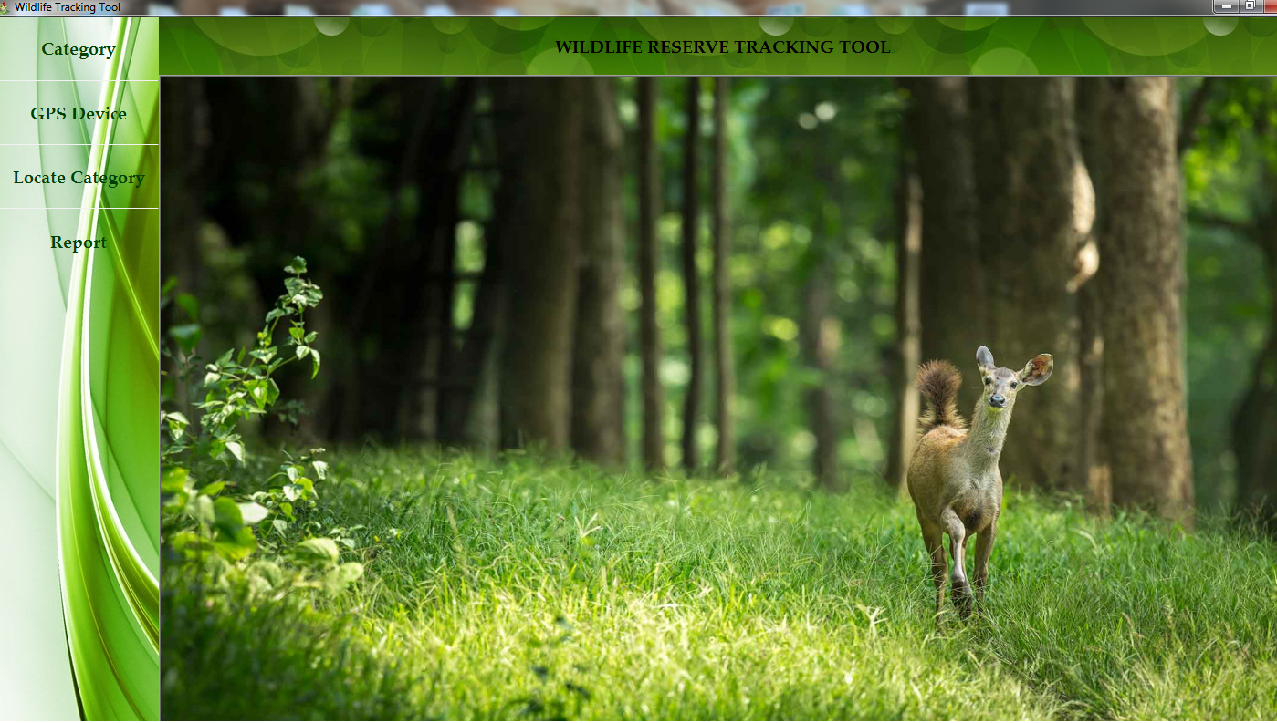**

Figure Main Screen

## Category

Users can add a category, delete a category, list all the categories . Users can delete the category only if there is no animal associated with the category.

### List Categories

It lists all the category and the associated color with each category. This category color is used to indicate the category while plotting the chart.

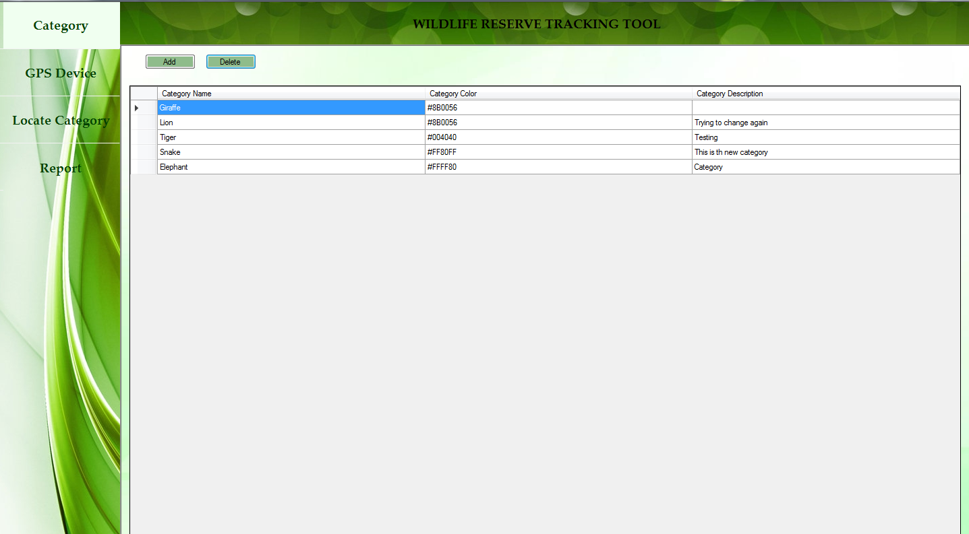

Figure 2 List of Categories

### Add Category

Select C:\Users\farheen.a\Desktop\Screens_Wildlife\AddButton.png button to add a new category .

Category name and category color with category description has to be specified while adding a new category.

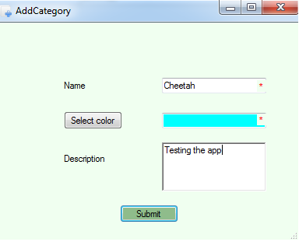

Figure 3 Add Category

After filling all the field in the creation pop up. Click submit button. Once the category is successfully added and saved, a confirmation message is shown.

### Delete Category

Select the row that is to be deleted. Select C:\Users\farheen.a\Desktop\Screens_Wildlife\deleteButton.png to delete the category.

If there is no animal associated with the category, the category is deleted successfully, otherwise a pop up appears indicating there is an error with the delete operation. Deleting is restricted in order to track all the animals and its history.

### Edit Category

Select the row that is to be deleted. Select Edit Button to edit the category. If all the mandatory fields are added, it successfully edits the category.

## GPS Device

Users can associate animals with each category . Each animal is given a unique GPS device Id using which the animal is tracked.

### List Animals

It lists all the animals associated with the category. It shows the GPS Id associated with each animal.

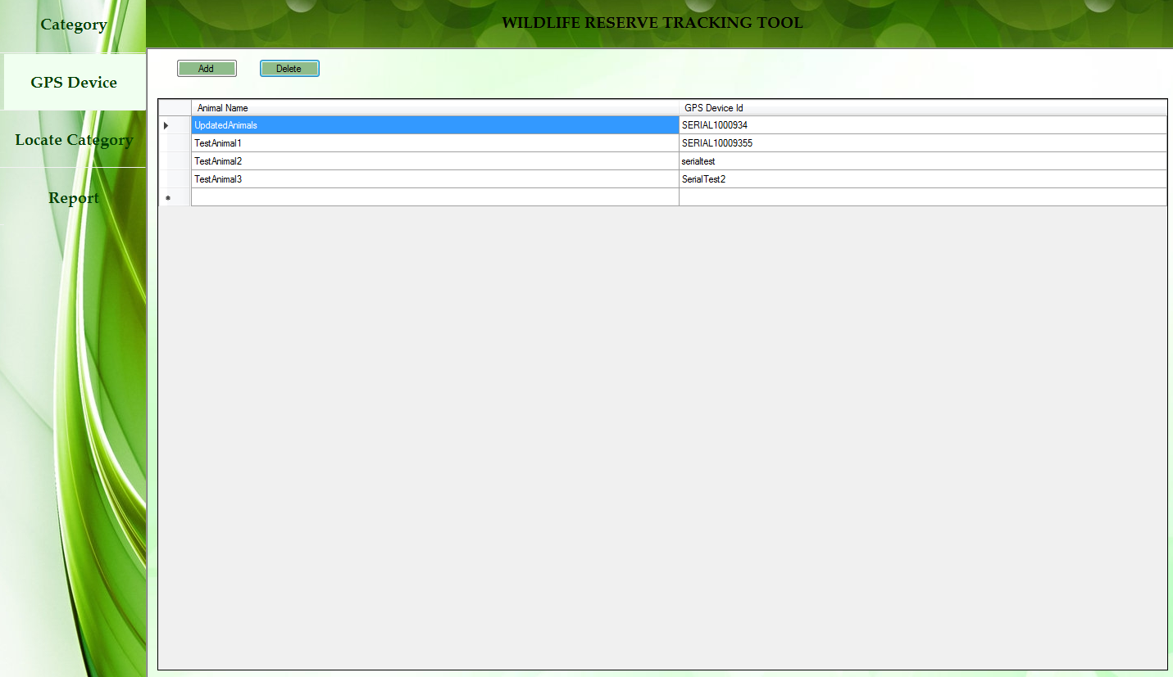

Figure 5 List of Animals

### Add Animals

Select C:\Users\farheen.a\Desktop\Screens_Wildlife\AddButton.png button to add a new animal .

Animal name and GPS ID is specified along with the category to which the animal belongs. The animal is then added to the selected category.

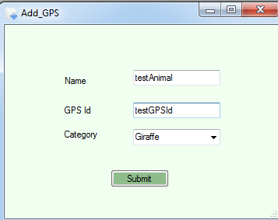

Figure 6 Add Animal

After filling all the field in the creation pop up. Click submit button. Once the animal is successfully added and saved, a confirmation message is shown. In case if the operation is failed, the message would be shown.

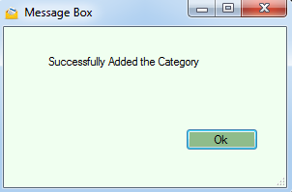

Figure 7 Successful Animal Added Message

### Delete Animals

Select the row that is to be deleted. Select C:\Users\farheen.a\Desktop\Screens_Wildlife\deleteButton.png to delete the animal.

If there is no GPS location associated with the animal, the animal is deleted successfully, otherwise a pop up appears indicating there is an error with the delete operation.

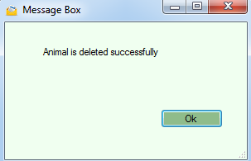

Figure 8 Successful Animal Deletion Message

## Locate Animal

User can view the animals on a Google Map to identify the locations of all the animals. The Map can be zoomed in and zoomed out. It can be dragged using mouse Right Click.

### Locate Animals In All Category

In Locate animal window, by default "All" is selected. It locates all the animals in all the categories. Each category is having a tooltip which shows the animal GPS device Id and its category.

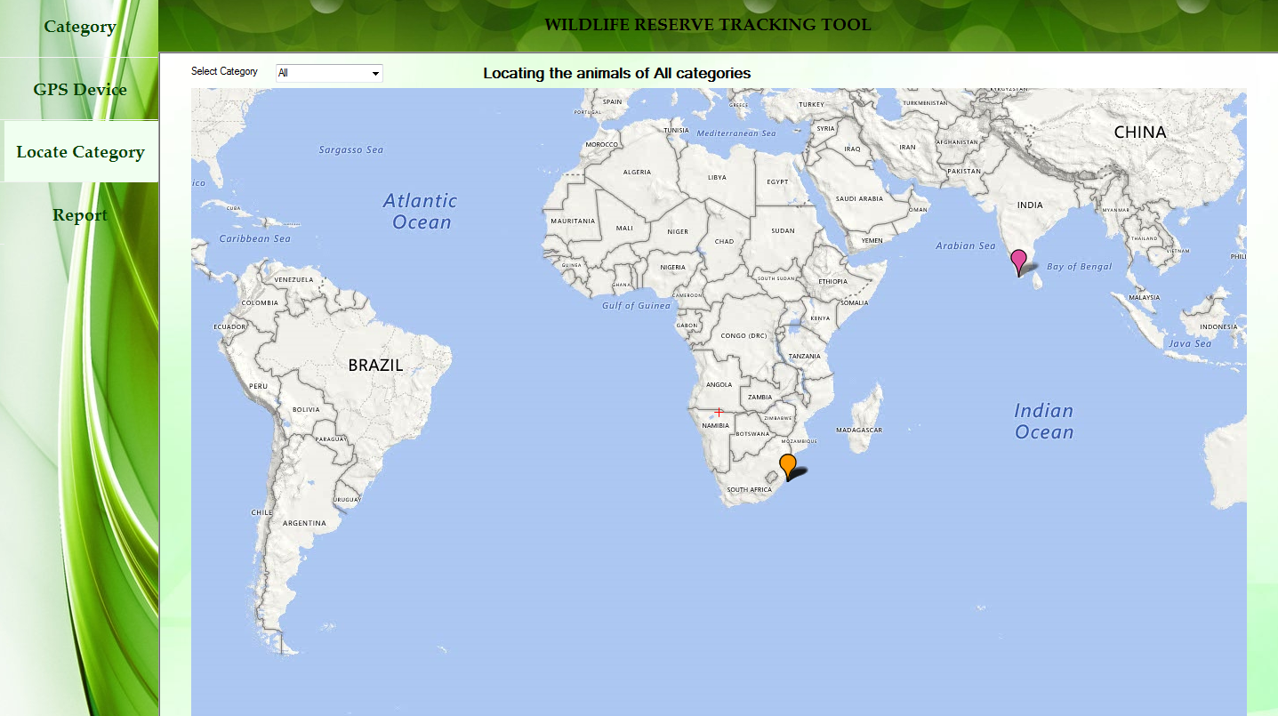

Figure 9 Locating All Categories

### Locate Animals Per Category

TheC:\Users\farheen.a\Desktop\Screens_Wildlife\AllCategoryMapAllocationScreen.png option lists all the categories. User can select any of the categories and it locates the animals in the selected category. Animals per category is by default set as green color. Animals for the specific category will be shown in green color.

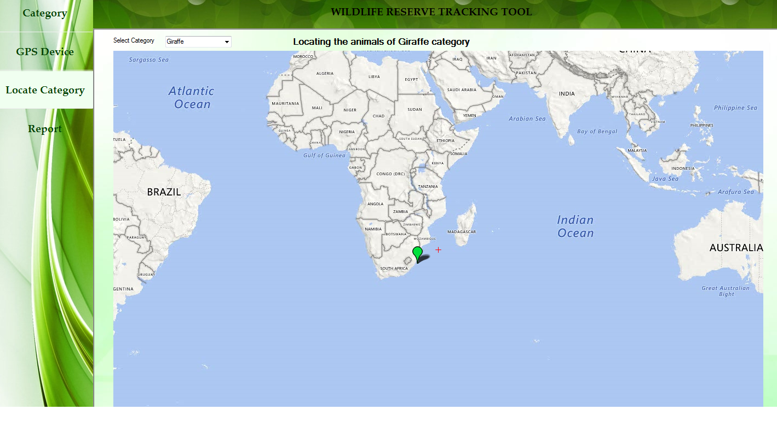

Figure 10 Locating Animals Per Category

Note: The animal color is shown as green when selected over the category

## Report

### Generate the Report

User can select this tab when they want to view the number of animals per category. Here user can view the number of animals per category over a period of time. User can select start date and end date and on clicking the Generate buttons, it generates the chart displaying the animals count.

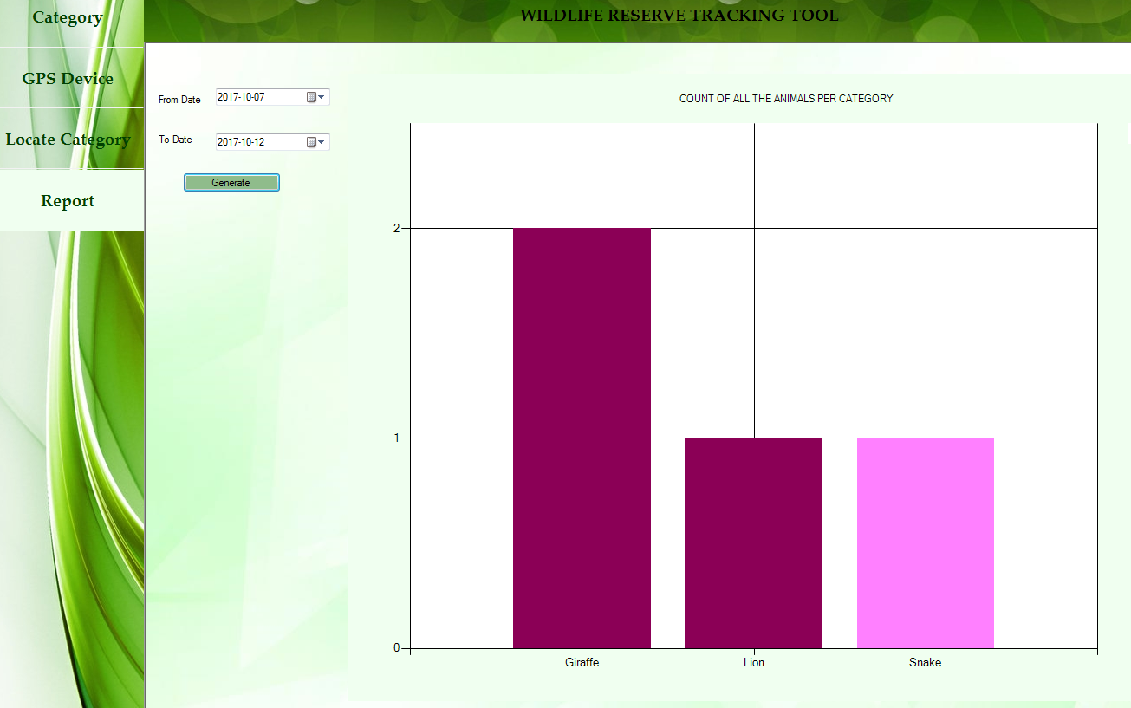

Figure 11 Generate Animals Per Category Count